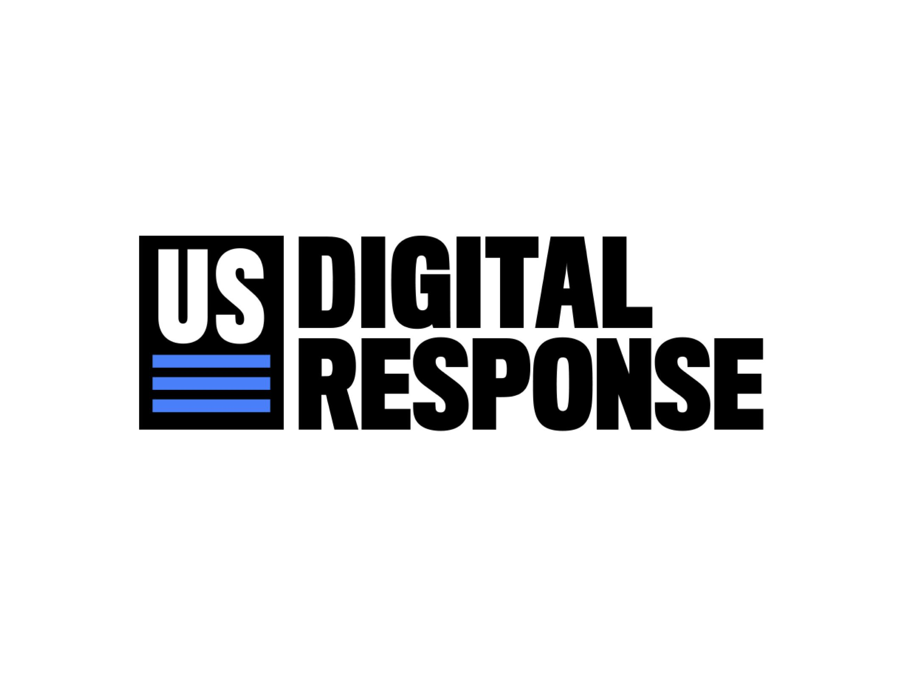

USDR + **Stimulus Tracking Authentication**

Problem Statement

The Cares-Reporter and Grant Opportunity apps authenticate users via a token sent by email each time a user attempts to log in. For each state the number of emails sent per day is very small - usually zero, and for two peak weeks each quarter about 20 emails per day.

There have been two problems with the email service:

1. It currently uses AWS SES as the mail server. SES uses a pool of shared IP addresses some of which occasionally get put onto black-lists by spam filters, preventing users from receiving their log-in token. This problem has been fixed by moving to an unshared fixed IP address and white-listing it with the spam filters. It is no longer a problem - the system is now working fine and will continue to do so.
2. The AWS SES mail server account belongs to USDR. But USDR policy prefers that we don't provide infrastructure to our customers. This is for security and maintainability - going forward the states should not have USDR as a point of failure, and USDR should not continue to disclose its private AWS credentials to the states. This is why the states own their Cares-Reporter server instances at Render.com and why they have access to the source code repo on GitHub. This will remain a problem until we move the authentication service to email servers controlled by each state.

Solution Options

The app can use any SMTP server to send the authentication emails, for example:

1. The state creates a new, dedicated AWS SES account for Cares-Reporter authentication.
2. The state uses an AWS SES account that they already own.
3. The state allocates a client email address on one of their enterprise email servers, like cares-reporter@it.ohio.gov, and gives the app user login credentials. The problem is that the state must limit use of email addresses like login-authentication@usdr.ri.gov, to reduce vulnerability to phishing.

Options 1 and 2 can be implemented without any code changes - the AWS credentials are on an admin form in the Render.com instance.

Option 3 requires modest code changes.

Connect with USDR

USDR can work within defined or ambiguous scopes — we’re here to help problem-solve together. USDR is committed to partnering directly with governments and organizations on the specific issues facing your communities. No issue is too big or too small. [**Fill out this brief intake form**](http://www.usdigitalresponse.org/request-help) **to get in touch with USDR and get started within 24 hours.**